# **UML Tools for Python**

* [PyUML](https://sourceforge.net/projects/eclipse-pyuml/) is an open source Eclipse plug-in offering round trip engineering betwee UML and Python.UML support is limited to class diagrams and the code-generation capabilities are simple class to class (or interface to interface) transformations
* [Epydoc](http://epydoc.sourceforge.net/) : Generate UML documentation from python code (last release on 2008)
* [PyNSource](http://www.andypatterns.com/index.php/products/pynsource/) : Reverse engineer python source code into UML. Generated UML class diagrams can be displayed as ASCII Art or in a more typical graphical form.
* [Lumpy](http://www.greenteapress.com/thinkpython/swampy/lumpy.html) : Python module that generates UML diagrams (currently object and class diagrams) from a running Python program. It is similar to a graphical debugger in the sense that it generates a visualization of the state of a running program, but it is different from a debugger in the sense that it tries to generate high-level visualizations that are compliant (at least in spirit) with standard UML
* [ObjectDomain](http://www.objectdomain.com/products/od-features) : commercial tool with forward and reverse engineering support for Python.
* [argoUML-python](http://argouml-python.tigris.org/) seems (seemed?) to go in the same direction but it is not quite there yet.
* [GraphModels (django-command-extensions)](https://code.google.com/p/django-command-extensions/wiki/GraphModels) creates a UML-like GraphViz dot file for the specified app name
* [Pyreverse](https://www.logilab.org/project/pylint) included in the Pylint source distribution (for the analysis of the quality of python code) creates UML diagrams from the code
* [pywebuml](https://bitbucket.org/tzulberti/pywebuml) uses graphviz to create a UML class diagram representing your python (and also Java and C#) code.

**How to generate UML from Python?**

Instant Reverse is a process to produce UML class model from a given input of source code. With instant reverse, you can reverse a snap shot of your code-base to UML classes and form class diagram in further. By bringing code content into visual UML model, this helps programmers or software engineers ...

**What are the best UML tools?**

Following is a curated list of Top 28 handpicked UML tools with popular features and latest download links. This comparison list contains open source as well as commercial tools. Adobe Spark is a flowchart software that helps you design customized and streamlined flowcharts. It also allows you to save and share your flowchart diagrams.

# UML Diagrams Examples

## *Examples by Technology or Application Domain*

[**Online shopping UML diagrams**](https://www.uml-diagrams.org/examples/online-shopping-example.html)  
[**Ticket vending machine UML diagrams**](https://www.uml-diagrams.org/ticket-vending-machine-uml-diagrams-examples.html)  
[**Bank ATM UML diagrams**](https://www.uml-diagrams.org/examples/bank-atm-example.html)  
[**Hospital management UML diagrams**](https://www.uml-diagrams.org/examples/hospital-management-example.html)  
[**Digital imaging and communications in medicine (DICOM) UML diagrams**](https://www.uml-diagrams.org/dicom-uml-diagrams-examples.html)  
[**Java technology UML diagrams**](https://www.uml-diagrams.org/examples/java-uml-examples.html)  
[**Application development for Android UML diagrams**](https://www.uml-diagrams.org/examples/android-uml-examples.html)  
[**Software licensing and protection using SafeNet Sentinel HASP security solution**](https://www.uml-diagrams.org/software-licensing-sentinel-uml-examples.html)

## *Examples by Types of Diagrams*

[**Activity diagram examples**](https://www.uml-diagrams.org/activity-diagrams-examples.html)  
[**Class diagram examples**](https://www.uml-diagrams.org/class-diagrams-examples.html)  
[**Communication diagram examples**](https://www.uml-diagrams.org/communication-diagrams-examples.html)  
[**Component diagram examples**](https://www.uml-diagrams.org/component-diagrams-examples.html)  
[**Composite structure diagram examples**](https://www.uml-diagrams.org/composite-structure-examples.html)  
[**Deployment diagram examples**](https://www.uml-diagrams.org/deployment-diagrams-examples.html)  
[**Information flow diagram example**](https://www.uml-diagrams.org/information-flow-diagrams/scheduled-workflow-example.html)  
[**Interaction overview diagram examples**](https://www.uml-diagrams.org/interaction-overview-diagrams-examples.html)  
[**Object diagram example**](https://www.uml-diagrams.org/online-shopping-user-login-uml-object-diagram-example.html)  
[**Package diagram examples**](https://www.uml-diagrams.org/package-diagrams-examples.html)  
[**Profile diagram examples**](https://www.uml-diagrams.org/profile-diagrams-examples.html)  
[**Sequence diagram examples**](https://www.uml-diagrams.org/sequence-diagrams-examples.html)  
[**State machine diagram examples**](https://www.uml-diagrams.org/state-machine-diagrams-examples.html)  
[**Timing diagram examples**](https://www.uml-diagrams.org/timing-diagrams-examples.html)  
[**Use case diagram examples**](https://www.uml-diagrams.org/use-case-diagrams-examples.html)

### Use Case Diagrams

#### Business Use Case Diagrams

Next  [**Airport check-in and security screening business model**](https://www.uml-diagrams.org/airport-checkin-uml-use-case-diagram-example.html)

**[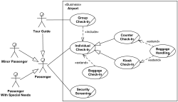](https://www.uml-diagrams.org/airport-checkin-uml-use-case-diagram-example.html)**

Next  [**Restaurant business model**](https://www.uml-diagrams.org/restaurant-uml-use-case-diagram-example.html)

**[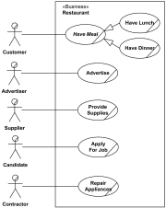](https://www.uml-diagrams.org/restaurant-uml-use-case-diagram-example.html)**

#### System Use Case Diagrams

Next  [**Ticket vending machine**](https://www.uml-diagrams.org/ticket-vending-machine-use-case-diagram-example.html?context=uc-examples)

**[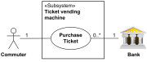](https://www.uml-diagrams.org/ticket-vending-machine-use-case-diagram-example.html?context=uc-examples)**

Next  [**Bank ATM UML use case diagrams examples**](https://www.uml-diagrams.org/bank-atm-uml-use-case-diagram-example.html?context=uc-examples)

**[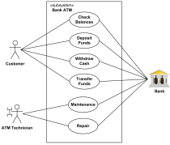](https://www.uml-diagrams.org/bank-atm-uml-use-case-diagram-example.html?context=uc-examples)**

Next  [**Point of Sales (POS) terminal**](https://www.uml-diagrams.org/examples/point-of-sales-uml-use-case-diagram-example.html)

**[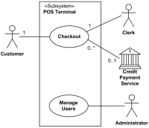](https://www.uml-diagrams.org/examples/point-of-sales-uml-use-case-diagram-example.html)**

Next  [**e-Library online public access catalog (OPAC)**](https://www.uml-diagrams.org/online-library-uml-use-case-diagram-example.html)

**[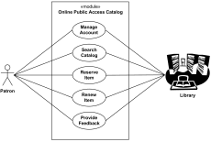](https://www.uml-diagrams.org/online-library-uml-use-case-diagram-example.html)**

Next  [**Online shopping use case diagrams**](https://www.uml-diagrams.org/examples/online-shopping-use-case-diagram-example.html?context=uc-examples)

**[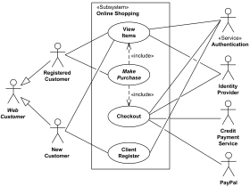](https://www.uml-diagrams.org/examples/online-shopping-use-case-diagram-example.html?context=uc-examples)**

Next  [**Credit card processing system**](https://www.uml-diagrams.org/examples/online-shopping-credit-cards-use-cases-example.html?context=uc-examples)

**[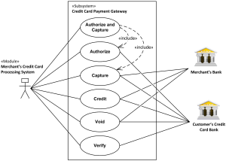](https://www.uml-diagrams.org/examples/online-shopping-credit-cards-use-cases-example.html?context=uc-examples)**

Next  [**Website administration**](https://www.uml-diagrams.org/examples/website-admin-use-case-diagrams-example.html?context=uc-examples)

**[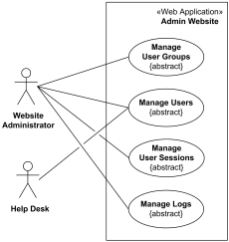](https://www.uml-diagrams.org/examples/website-admin-use-case-diagrams-example.html?context=uc-examples)**

Next  [**Hospital Management**](https://www.uml-diagrams.org/examples/hospital-management-use-case-diagram-example.html?context=uc-examples)

**[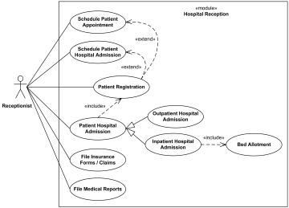](https://www.uml-diagrams.org/examples/hospital-management-use-case-diagram-example.html)**

Next  [**Radiology diagnostic reporting UML use case diagram example**](https://www.uml-diagrams.org/radiology-diagnostic-report-uml-use-case-diagram-example.html?context=uc-examples)

**[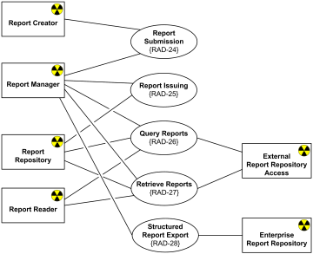](https://www.uml-diagrams.org/radiology-diagnostic-report-uml-use-case-diagram-example.html?context=uc-examples)**

Next  [**Software protection and licensing UML use case diagram example**](https://www.uml-diagrams.org/examples/software-license-use-case-diagram-example.html?context=uc-examples)

**[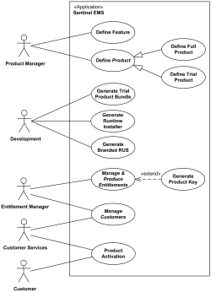](https://www.uml-diagrams.org/examples/software-license-use-case-diagram-example.html?context=uc-examples)**

### Information Flow Diagrams

[**Scheduled Workflow information flow for the IHE Radiology Technical Framework**](https://www.uml-diagrams.org/information-flow-diagrams/scheduled-workflow-example.html?context=ifl-examples)

**[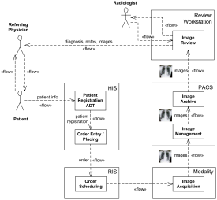](https://www.uml-diagrams.org/information-flow-diagrams/scheduled-workflow-example.html?context=ifl-examples)**

### Class Diagrams

Next  [**Abstract Factory Design Pattern**](https://www.uml-diagrams.org/design-pattern-abstract-factory-uml-class-diagram-example.html)

**[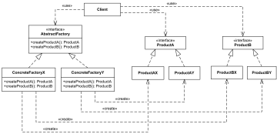](https://www.uml-diagrams.org/design-pattern-abstract-factory-uml-class-diagram-example.html)**

#### Domain Models

Next  [**Library domain model**](https://www.uml-diagrams.org/library-domain-uml-class-diagram-example.html)

**[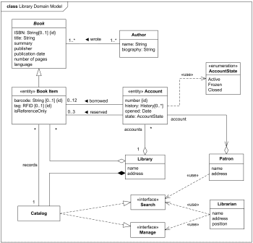](https://www.uml-diagrams.org/library-domain-uml-class-diagram-example.html)**

Next  [**Bank account class diagram example**](https://www.uml-diagrams.org/examples/bank-account-domain-diagram-example.html?context=cls-examples)

**[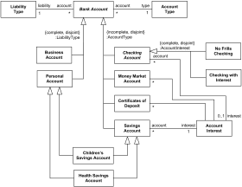](https://www.uml-diagrams.org/examples/bank-account-domain-diagram-example.html?context=cls-examples)**

Next  [**Online shopping domain model**](https://www.uml-diagrams.org/examples/online-shopping-domain-uml-diagram-example.html?context=cls-examples)

**[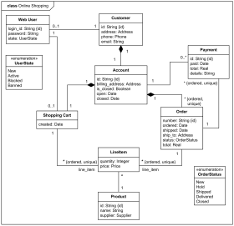](https://www.uml-diagrams.org/examples/online-shopping-domain-uml-diagram-example.html?context=cls-examples)**

Next  [**Health insurance policy UML class diagram example**](https://www.uml-diagrams.org/examples/health-insurance-policy-domain-diagram-example.html?context=cls-examples)

**[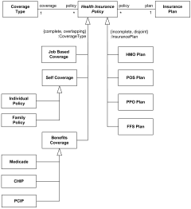](https://www.uml-diagrams.org/examples/health-insurance-policy-domain-diagram-example.html?context=cls-examples)**

Next  [**Hospital domain UML class diagram example**](https://www.uml-diagrams.org/examples/hospital-domain-diagram.html?context=cls-examples)

**[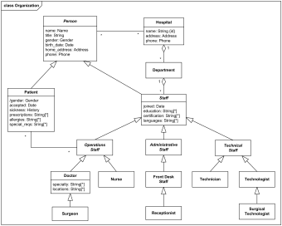](https://www.uml-diagrams.org/examples/hospital-domain-diagram.html?context=cls-examples)**

Next  [**Digital imaging in medicine - DICOM model of the real world**](https://www.uml-diagrams.org/dicom-real-world-uml-class-diagram-example.html?context=cls-examples)

**[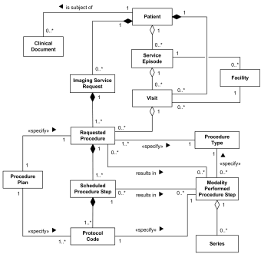](https://www.uml-diagrams.org/dicom-real-world-uml-class-diagram-example.html?context=cls-examples)**

Next  [**Sentinel HASP software licensing domain UML class diagram example**](https://www.uml-diagrams.org/software-licensing-domain-diagram-example.html?context=cls-examples)

**[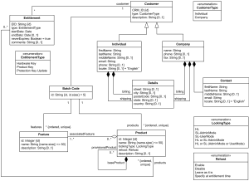](https://www.uml-diagrams.org/software-licensing-domain-diagram-example.html?context=cls-examples)**

#### APIs

Next  [**Digital imaging in medicine - DICOM Application Hosting API**](https://www.uml-diagrams.org/dicom-application-hosting-api-uml-class-diagram-example.html?context=cls-examples)

**[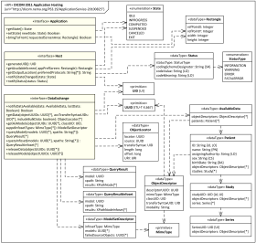](https://www.uml-diagrams.org/dicom-application-hosting-api-uml-class-diagram-example.html?context=cls-examples)**

Next  [**Java util.concurrent API UML class diagram examples**](https://www.uml-diagrams.org/java-7-concurrent-uml-class-diagram-example.html?context=cls-examples)

**[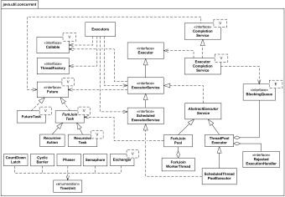](https://www.uml-diagrams.org/java-7-concurrent-uml-class-diagram-example.html?context=cls-examples)**

#### Implementation Models

Next  [**Android Camera implementation classes**](https://www.uml-diagrams.org/android-camera-uml-class-diagram-example.html)

**[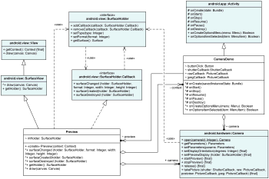](https://www.uml-diagrams.org/android-camera-uml-class-diagram-example.html)**

Next  [**Sentinel HASP licensing UML class diagram of Aladdin package**](https://www.uml-diagrams.org/software-licensing-class-diagram-example.html?context=cls-examples)

**[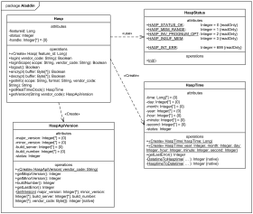](https://www.uml-diagrams.org/software-licensing-class-diagram-example.html?context=cls-examples)**

### Object Diagrams

Next  [**Web application Login Controller object diagram**](https://www.uml-diagrams.org/online-shopping-user-login-uml-object-diagram-example.html?context=cls-examples)

**[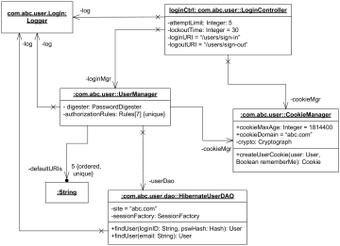](https://www.uml-diagrams.org/online-shopping-user-login-uml-object-diagram-example.html?context=cls-examples)**

### Composite Structure Diagrams

Next  [**Bank ATM UML composite structure diagram example**](https://www.uml-diagrams.org/bank-atm-uml-composite-diagram-example.html?context=cst-examples)

**[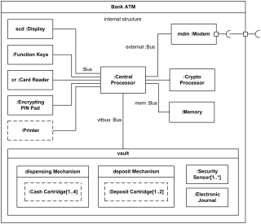](https://www.uml-diagrams.org/bank-atm-uml-composite-diagram-example.html?context=cst-examples)**

Next  [**Apache Tomcat 7 web server UML composite structure diagram example**](https://www.uml-diagrams.org/tomcat-server-uml-composite-structure-diagram-example.html?context=cst-examples)

**[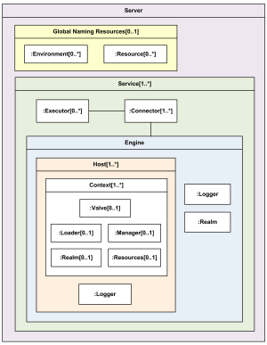](https://www.uml-diagrams.org/tomcat-server-uml-composite-structure-diagram-example.html?context=cst-examples)**

Next  [**Observer design pattern as UML collaboration use example**](https://www.uml-diagrams.org/observer-pattern-uml-composite-diagram-example.html)

**[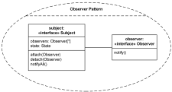](https://www.uml-diagrams.org/observer-pattern-uml-composite-diagram-example.html)**

### Package Diagrams

Next  [**Multi-Layered Application Model**](https://www.uml-diagrams.org/multi-layered-application-uml-model-diagram-example.html)

**[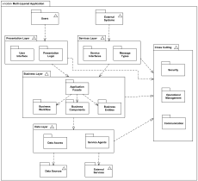](https://www.uml-diagrams.org/multi-layered-application-uml-model-diagram-example.html)**

Next  [**Multi-Layered Web Architecture**](https://www.uml-diagrams.org/multi-layered-web-architecture-uml-package-diagram-example.html)

**[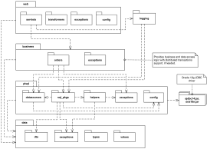](https://www.uml-diagrams.org/multi-layered-web-architecture-uml-package-diagram-example.html)**

Next  [**Java™ Platform Standard Edition 7 API UML package diagram example.**](https://www.uml-diagrams.org/java-7-api-uml-package-diagram-example.html?context=pkg-examples)

**[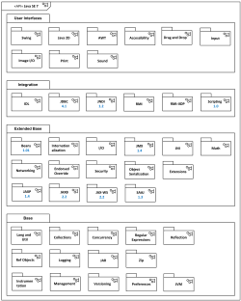](https://www.uml-diagrams.org/java-7-api-uml-package-diagram-example.html?context=pkg-examples)**

Next  [**Java Servlet 2.5 API UML package diagram example**](https://www.uml-diagrams.org/examples/java-servlet-25-api-package-diagram-example.html?context=pkg-examples)

**[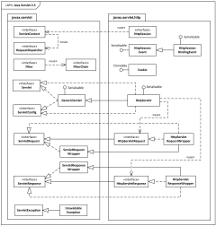](https://www.uml-diagrams.org/examples/java-servlet-25-api-package-diagram-example.html?context=pkg-examples)**

Next  [**Java Servlet 3.0 API UML package diagram example**](https://www.uml-diagrams.org/examples/java-servlet-30-api-package-diagram-example.html?context=pkg-examples)

**[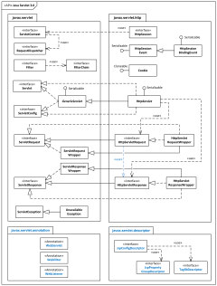](https://www.uml-diagrams.org/examples/java-servlet-30-api-package-diagram-example.html?context=pkg-examples)**

Next  [**Spring and Hibernate ORM data access packages and classes**](https://www.uml-diagrams.org/spring-hibernate-uml-package-diagram-example.html)

**[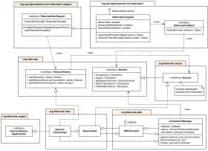](https://www.uml-diagrams.org/spring-hibernate-uml-package-diagram-example.html?context=activity-examples)**

Next  [**(Data) Transfer Object (Value Object) design pattern package template**](https://www.uml-diagrams.org/transfer-object-pattern-uml-package-template-example.html)

**[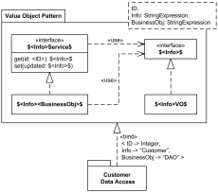](https://www.uml-diagrams.org/transfer-object-pattern-uml-package-template-example.html)**

### Component Diagrams

Next  [**Online shopping component diagram**](https://www.uml-diagrams.org/examples/online-shopping-uml-component-diagram-example.html?context=cmp-examples)

**[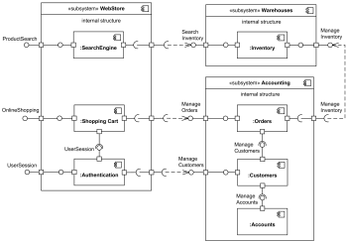](https://www.uml-diagrams.org/examples/online-shopping-uml-component-diagram-example.html?context=cmp-examples)**

Next  [**Sentinel HASP licensing components**](https://www.uml-diagrams.org/software-licensing-component-diagram-example.html?context=cmp-examples)

**[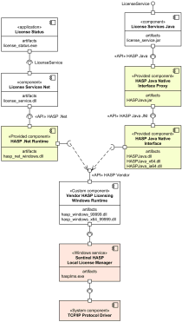](https://www.uml-diagrams.org/software-licensing-component-diagram-example.html?context=cmp-examples)**

### Deployment Diagrams

Next  [**Online shopping web application manifestation**](https://www.uml-diagrams.org/web-application-uml-manifest-diagram-example.html?context=depl-examples)

**[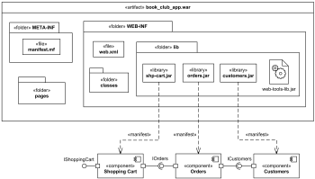](https://www.uml-diagrams.org/web-application-uml-manifest-diagram-example.html?context=depl-examples)**

Next  [**Online shopping web application UML deployment diagram**](https://www.uml-diagrams.org/web-application-uml-deployment-diagram-example.html?context=depl-examples)

**[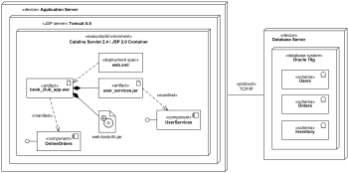](https://www.uml-diagrams.org/web-application-uml-deployment-diagram-example.html?context=depl-examples)**

Next  [**Clustered deployment of J2EE web application**](https://www.uml-diagrams.org/web-application-clusters-uml-deployment-diagram-example.html?context=depl-examples)

**[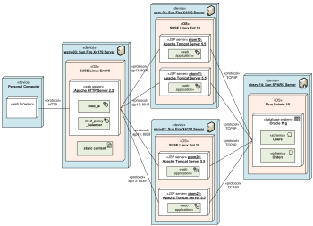](https://www.uml-diagrams.org/web-application-clusters-uml-deployment-diagram-example.html?context=depl-examples)**

Next  **[Multilayered load balancing of J2EE servers](https://www.uml-diagrams.org/web-application-load-balancing-uml-deployment-diagram-example.html?context=depl-examples)**

**[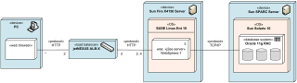](https://www.uml-diagrams.org/web-application-load-balancing-uml-deployment-diagram-example.html?context=depl-examples)**

Next  [**Apple iTunes UML deployment diagram**](https://www.uml-diagrams.org/apple-itunes-uml-deployment-diagram-example.html)

**[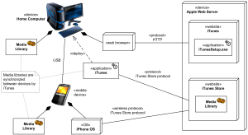](https://www.uml-diagrams.org/apple-itunes-uml-deployment-diagram-example.html)**

Next  [**Android application deployment**](https://www.uml-diagrams.org/android-application-uml-deployment-diagram-example.html)

**[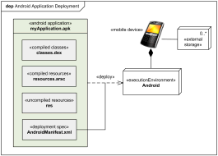](https://www.uml-diagrams.org/android-application-uml-deployment-diagram-example.html)**

#### Network Diagrams

Next  [**Home network diagram example**](https://www.uml-diagrams.org/examples/home-network-diagram-example.html?context=depl-examples)

**[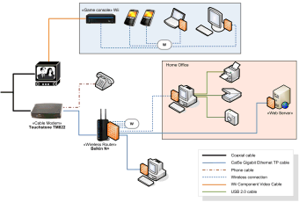](https://www.uml-diagrams.org/examples/home-network-diagram-example.html?context=depl-examples)**

Next  [**Web application network diagram example**](https://www.uml-diagrams.org/examples/web-application-network-diagram-example.html?context=depl-examples)

**[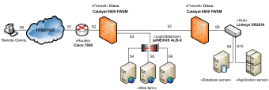](https://www.uml-diagrams.org/examples/web-application-network-diagram-example.html?context=depl-examples)**

### Profile Diagrams

Next  [**Service Oriented Architecture Modeling Language (SoaML) UML profile diagram examples**](https://www.uml-diagrams.org/soaml-uml-profile-diagram-example.html)

**[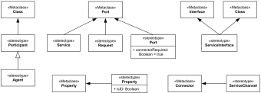](https://www.uml-diagrams.org/soaml-uml-profile-diagram-example.html)**

Next  [**Java Enterprise JavaBeans (EJB) 3.0 UML Profile**](https://www.uml-diagrams.org/java-ejb-uml-profile-diagram-example.html?context=prf-examples)

**[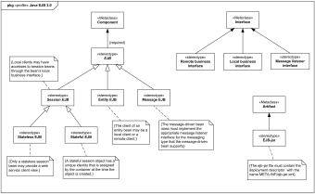](https://www.uml-diagrams.org/java-ejb-uml-profile-diagram-example.html?context=prf-examples)**

Next  [**Digital Imaging and Communications in Medicine (DICOM) UML profile diagram example**](https://www.uml-diagrams.org/dicom-uml-profile-diagram-example.html?context=prf-examples)

**[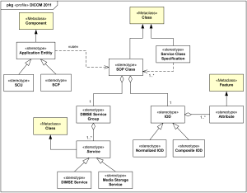](https://www.uml-diagrams.org/dicom-uml-profile-diagram-example.html?context=prf-examples)**

### Activity Diagrams

Next  [**Business flow - Process purchase order**](https://www.uml-diagrams.org/shopping-process-order-uml-activity-diagram-example.html?context=activity-examples)

**[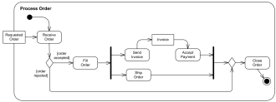](https://www.uml-diagrams.org/shopping-process-order-uml-activity-diagram-example.html?context=activity-examples)**

Next  [**Business flow - Document management process**](https://www.uml-diagrams.org/document-management-uml-activity-diagram-example.html)

**[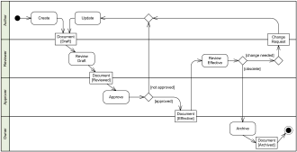](https://www.uml-diagrams.org/document-management-uml-activity-diagram-example.html)**

Next  [**Electronic prescription service**](https://www.uml-diagrams.org/electronic-prescriptions-activity-diagram-example.html?context=activity-examples)

**[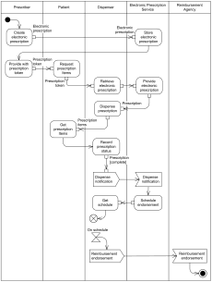](https://www.uml-diagrams.org/electronic-prescriptions-activity-diagram-example.html?context=activity-examples)**

Next  [**Software design - Resolve software issue**](https://www.uml-diagrams.org/software-resolve-issue-uml-activity-diagram-example.html)

**[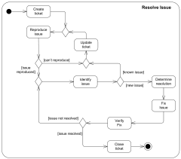](https://www.uml-diagrams.org/software-resolve-issue-uml-activity-diagram-example.html)**

Next  [**Software licensing - activation of Sentinel HASP SL provisional product UML activity diagram example**](https://www.uml-diagrams.org/software-licensing-activity-diagram-example.html?context=activity-examples)

**[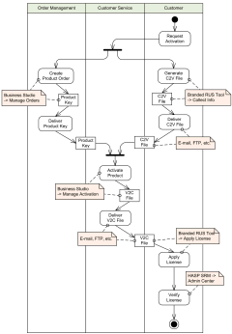](https://www.uml-diagrams.org/software-licensing-activity-diagram-example.html?context=activity-examples)**

Next  [**Online shopping UML activity diagram**](https://www.uml-diagrams.org/online-shopping-uml-activity-diagram-example.html?context=activity-examples)

**[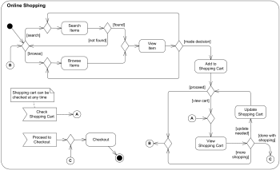](https://www.uml-diagrams.org/online-shopping-uml-activity-diagram-example.html?context=activity-examples)**

Next  [**Ticket vending machine**](https://www.uml-diagrams.org/ticket-vending-machine-activity-diagram-example.html?context=activity-examples)

**[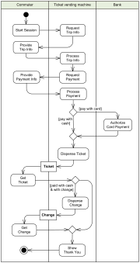](https://www.uml-diagrams.org/ticket-vending-machine-activity-diagram-example.html?context=activity-examples)**

Next  [**Web security - Single Sign-On (SSO) for Google Apps**](https://www.uml-diagrams.org/google-sign-on-uml-activity-diagram-example.html)

**[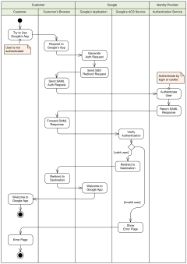](https://www.uml-diagrams.org/google-sign-on-uml-activity-diagram-example.html)**

### State Machine Diagrams

Next  [**Water Phase Diagram as State Machine**](https://www.uml-diagrams.org/examples/water-phase-uml-state-machine-diagram-example.html)

**[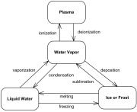](https://www.uml-diagrams.org/examples/water-phase-uml-state-machine-diagram-example.html)**

Next  [**Bank ATM behavioral state machine UML diagram example**](https://www.uml-diagrams.org/bank-atm-uml-state-machine-diagram-example.html?context=stm-examples)

**[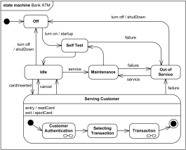](https://www.uml-diagrams.org/bank-atm-uml-state-machine-diagram-example.html?context=stm-examples)**

Next  [**Online shopping user account UML state machine diagram example**](https://www.uml-diagrams.org/examples/online-shopping-user-account-state-diagram-example.html?context=stm-examples)

**[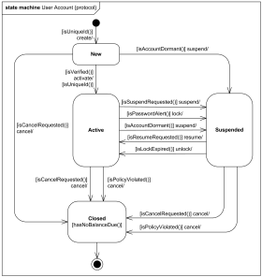](https://www.uml-diagrams.org/examples/online-shopping-user-account-state-diagram-example.html?context=stm-examples)**

Next  [**Java Thread states and life cycle UML protocol state machine example**](https://www.uml-diagrams.org/java-thread-uml-state-machine-diagram-example.html?context=stm-examples)

**[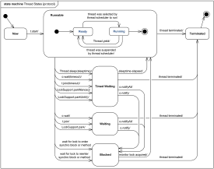](https://www.uml-diagrams.org/java-thread-uml-state-machine-diagram-example.html?context=stm-examples)**

Next  [**Java EJB life cycle of a session object UML state machine example**](https://www.uml-diagrams.org/java-ejb-state-machine-diagram-example.html?context=stm-examples)

**[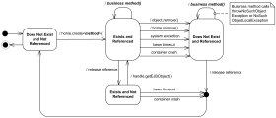](https://www.uml-diagrams.org/java-ejb-state-machine-diagram-example.html?context=stm-examples)**

Next  [**Digital Imaging and Communications in Medicine (DICOM) Hosted Application life cycle UML protocol state machine example**](https://www.uml-diagrams.org/dicom-hosted-application-uml-state-machine-diagram-example.html?context=stm-examples)

**[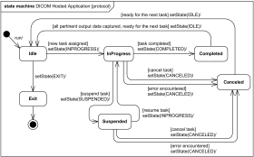](https://www.uml-diagrams.org/dicom-hosted-application-uml-state-machine-diagram-example.html?context=stm-examples)**

### Sequence Diagrams

Next  [**Online bookshop UML sequence diagram**](https://www.uml-diagrams.org/online-shopping-uml-sequence-diagram-example.html?context=seq-examples)

**[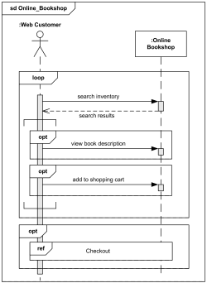](https://www.uml-diagrams.org/online-shopping-uml-sequence-diagram-example.html?context=seq-examples)**

Next  [**Submit comments to Pluck using DWR, AJAX, JSON**](https://www.uml-diagrams.org/pluck-comments-uml-sequence-diagram-example.html)

**[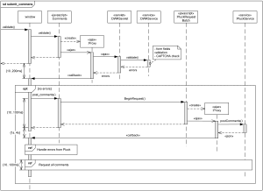](https://www.uml-diagrams.org/pluck-comments-uml-sequence-diagram-example.html)**

Next  [**Facebook user authentication in a web application**](https://www.uml-diagrams.org/facebook-authentication-uml-sequence-diagram-example.html)

**[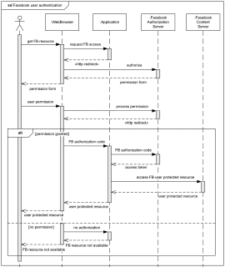](https://www.uml-diagrams.org/facebook-authentication-uml-sequence-diagram-example.html)**

Next  [**Spring and Hibernate transaction management**](https://www.uml-diagrams.org/examples/spring-hibernate-transaction-sequence-diagram-example.html)

**[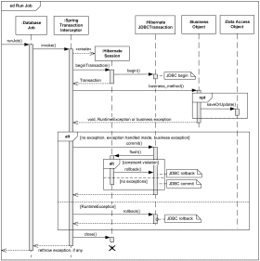](https://www.uml-diagrams.org/examples/spring-hibernate-transaction-sequence-diagram-example.html)**

### Timing Diagrams

Next  [**Medical domain - Stages of Alzheimer’s disease UML timing diagram example**](https://www.uml-diagrams.org/alzheimers-uml-timing-diagram-example.html)

**[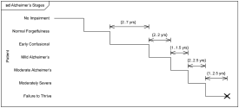](https://www.uml-diagrams.org/alzheimers-uml-timing-diagram-example.html)**

Next  [**Web user experience - Website latency UML timing diagram example**](https://www.uml-diagrams.org/website-latency-uml-timing-diagram-example.html)

**[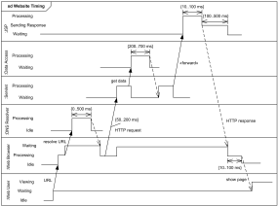](https://www.uml-diagrams.org/website-latency-uml-timing-diagram-example.html)**

### Communication Diagrams

Next  [**Online bookshop communication diagram**](https://www.uml-diagrams.org/examples/online-shopping-uml-communication-diagram-example.html?context=cmm-examples)

**[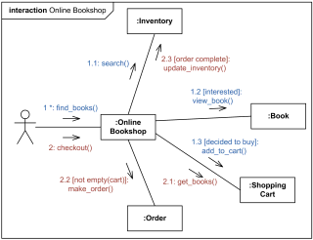](https://www.uml-diagrams.org/examples/online-shopping-uml-communication-diagram-example.html?context=cmm-examples)**

### Interaction Overview Diagrams

Next  [**Online shopping interaction overview diagram**](https://www.uml-diagrams.org/online-shopping-uml-interaction-overview-diagram-example.html?context=iov-examples)

**[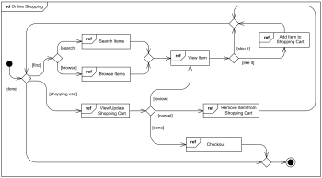](https://www.uml-diagrams.org/online-shopping-uml-interaction-overview-diagram-example.html?context=iov-examples)**

Next  [**Submit comments to Pluck using DWR, AJAX, JSON**](https://www.uml-diagrams.org/pluck-comments-uml-interaction-overview-example.html)

**[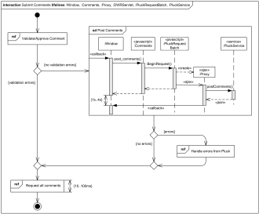](https://www.uml-diagrams.org/pluck-comments-uml-interaction-overview-example.html)**